20.55: a) Consider an infinitesimal heat flow 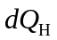that occurs when the temperature of the hot reservoir is 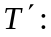

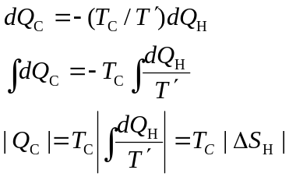

b) The 1.00 kg of water (the high-temperature reservoir) goes from 373 K to 273 K.

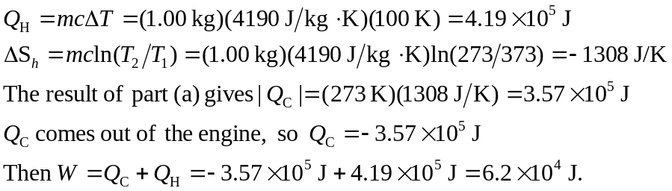

c) 2.00 kg of water goes from 323 K to 273 K
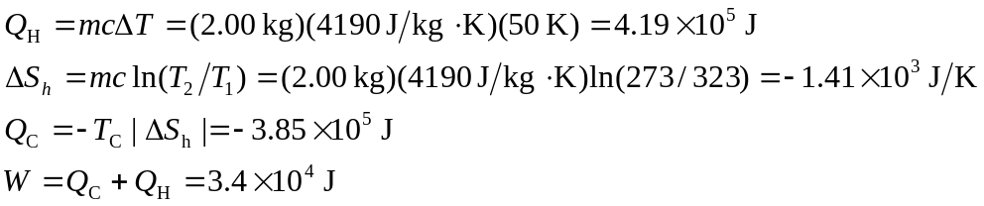

d) More work can be extracted from 1.00 kg of water at 373 K than from 2.00 kg of water at 323 K even though the energy that comes out of the water as it cools to 273 K is the same in both cases. The energy in the 323 K water is less available for conversion into mechanical work.

